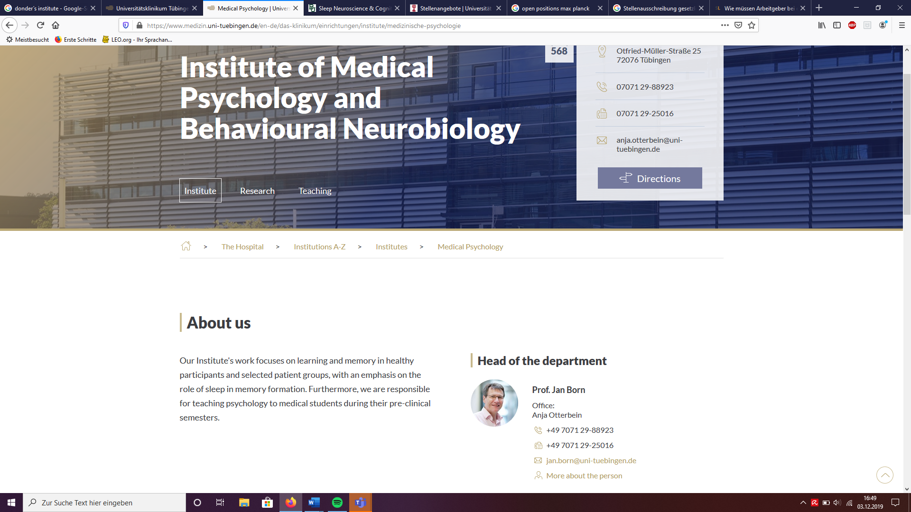

career



A hyperlink should lead to the respective current job description.

In case there is no vacancy:

“At the moment, we are not offering a specific position. Feel free to contact members of the institute directly for collaborations.”

career

To see the current vacancies of the Institute Of Medical Psychology, please click below.

- Internship: “*title*”

- Master thesis: “*title*”

- Bachelor thesis: “*title*”

- PhD position: “*title*”

- post-doc position

- technical staff

Career

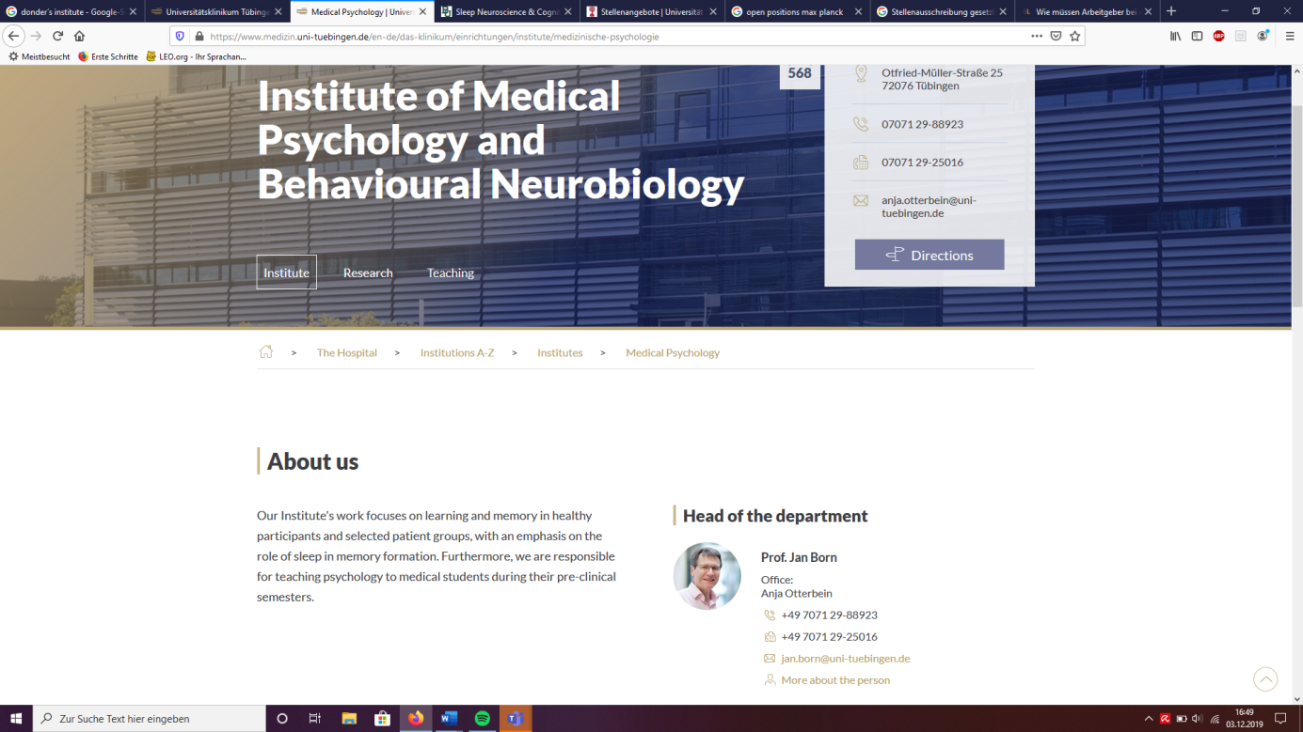

The Institute of Medical Psychology is part of the University Hospital Tübingen and the University of Tübingen. It has a long-standing tradition and profound expertise in the research on learning and memory in healthy participants and selected patient groups, with an emphasis on the role of sleep in memory formation. Furthermore, we are responsible for teaching psychology to medical students during their pre-clinical semesters.

We are offering a

*XXX* Position (f/m/d)

The position is available starting *date,  
Application deadline*

*Information of the group*

Description of the position *(🡪 PI)*

* …
* …
* …

Your profile

* …
* …
* …
* …

Our offer

* Working in an inspiring and international environment
* Payment *(scholarship, TVöD, xx%)*
* Yearly retreat, international conferences

For further information feel free to contact *(PI)*

*Name  
e-mail  
phone*

Please, send your complete application including cover letter, CV and certificates to:

*XX*  
Otfried-Müller-Straße 25  
72072 Tübignen  
*xxx*@uni-tuebingen.de

career

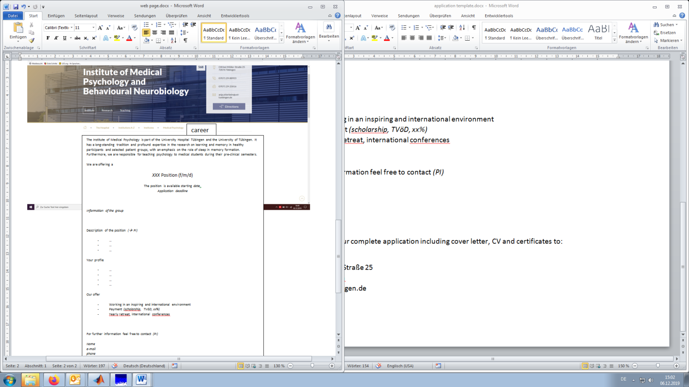

The open positions should be linked to the official Uni and Clinics site:   
<https://uni-tuebingen.de/universitaet/stellenangebote/>